# Appendix 1 to Section 19-6

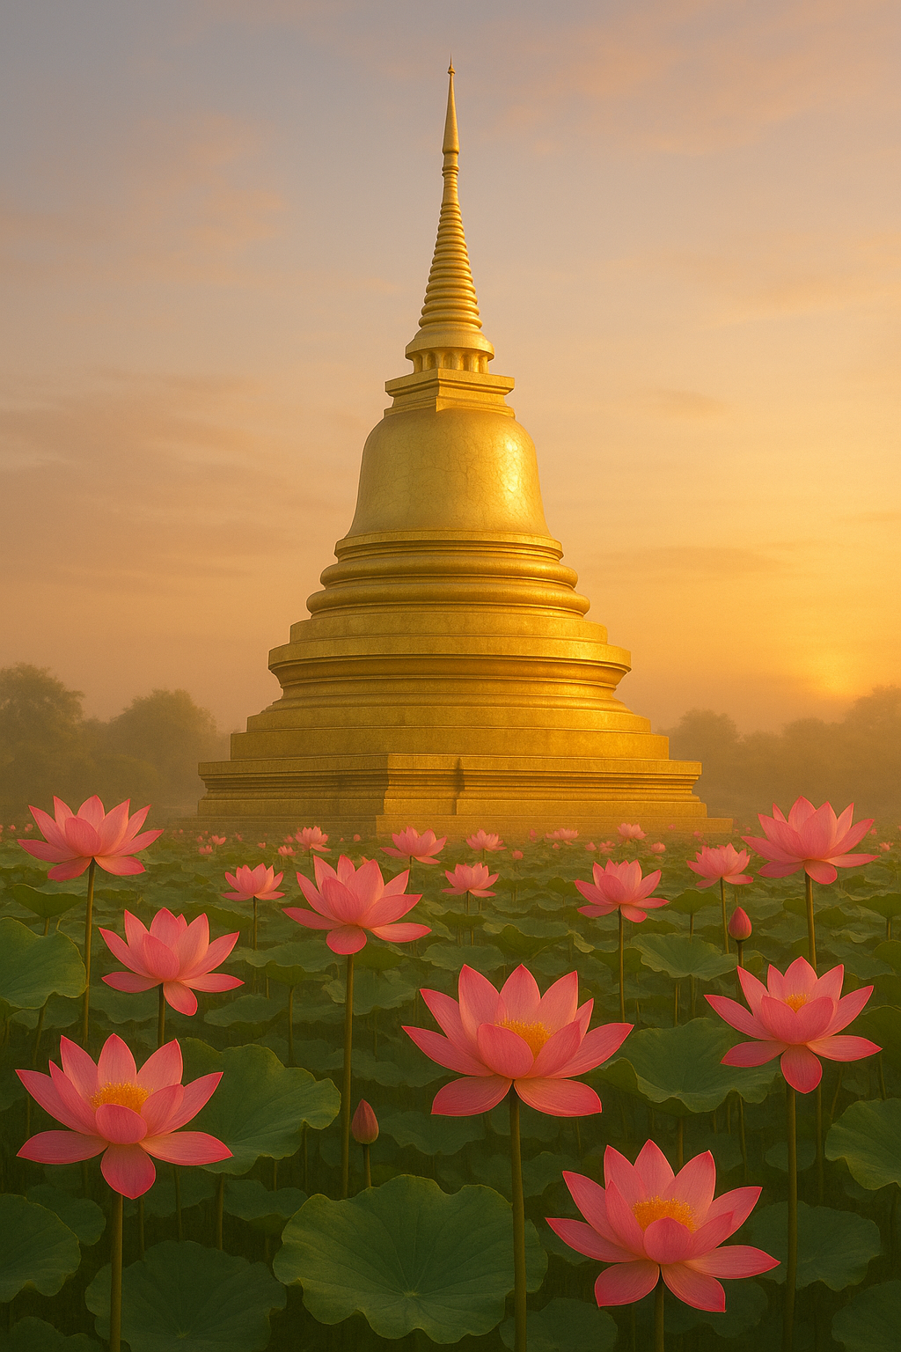

**May the remembrance of all sacred relics stupas deepen our trust in the Dhamma, inspire our practice, and lead us gently toward the highest peace! [1]**

## The Relics of the Blessed One

***Honouring the Compassion of the Tathāgata***

According to the *Mahāparinibbāna Sutta* (DN :6), after the Mahāparinibbāna—the final passing away—of the Blessed One, his sacred relics were divided and enshrined across ten different locations by kings, clans, and communities who held the Buddha in deepest reverence. The sutta tells us:

*“Then King Ajātasattu of Magadha built a great stupa for the Lord’s relics at Rājagaha (1). The Licchavis of Vesālī built one at Vesālī (2), the Sakyans of Kapilavatthu built one at Kapilavatthu (3), the Bulayas of Allakappa built one at Allakappa (4), the Koliyas of Rāmagāma built one at Rāmagāma (5), the Brahmins of Vethadīpa built one at Vethadīpa (6), the Mallas of Pāvā built one at Pāvā (7), and the Mallas of Kusinārā built a great stupa at Kusinārā (8). the Moriyas of Pipphalivana built one for the embers (9) and The Brahmin Doṇa built a stupa for the urn (10). Thus, eight stupas were built for the relics, a ninth for the for the embers and tenth for the urn*” (DN:16) See Section 19.6 for details)

Let us now turn to the modern sites associated with these ancient stupas—tracing the sacred memory of the Blessed One still resonating in the earth beneath our feet. The Map 1 shows provisional locations of the sites of Relics Stupas based on scriptural information and modern-day research.

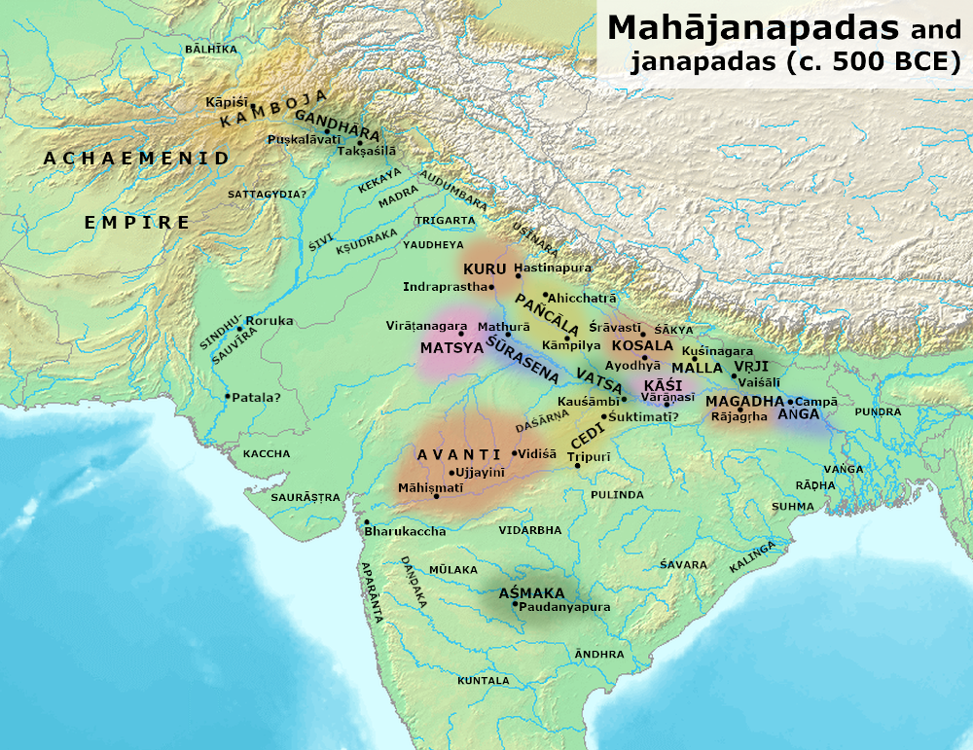

Map of Ancient India during the time of the Buddha **[2]**

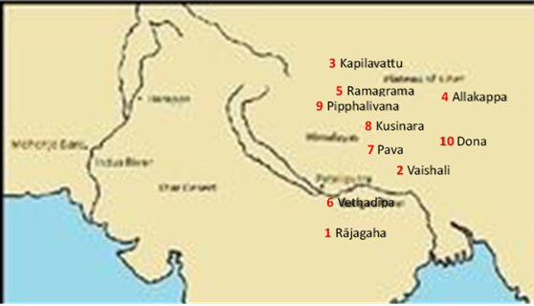

**Locations of the Ten Relics Stupas**

### 1. Relic Stupa of King Ajātasattu – Rājagaha (Rajgir, Bihar)

In the ancient city of Rājagaha, King Ajātasattu—who came to deeply honour the Buddha—built a great stupa to enshrine the Lord’s relics. For centuries, the exact location of this stupa remained hidden. [3] But during the years 1999–2001, archaeological excavations led by K.K. Muhammed of the Archaeological Survey of India (ASI) uncovered the remains of a large brick stupa, believed to be the very one built by King Ajātasattu. [4] A fragment of a relic casket was also recovered.

Though definitive evidence remains elusive and further findings have yet to emerge, the scriptures stand as testimony: **a great stupa once stood here to honour the Compassionate One**. Perhaps it still rests beneath the soil of Rajgir, guarded by time, awaiting a seeker whose heart is open.

As the Blessed One taught, **“All conditioned things are impermanent.”** The ruins may fade, but the Dhamma endures. And maybe, for the pilgrim walking these ancient paths, the earth itself whispers the echoes of the Tathāgata’s compassion, encouraging us to walk the path with renewed confidence.

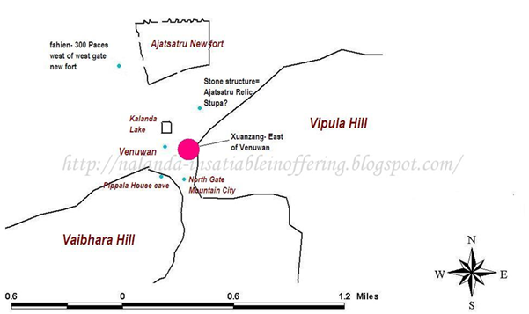

**Sketch map showing the location of the stone structure believed to be the stupa contain Buddha relic in present day Rajgir** [5].

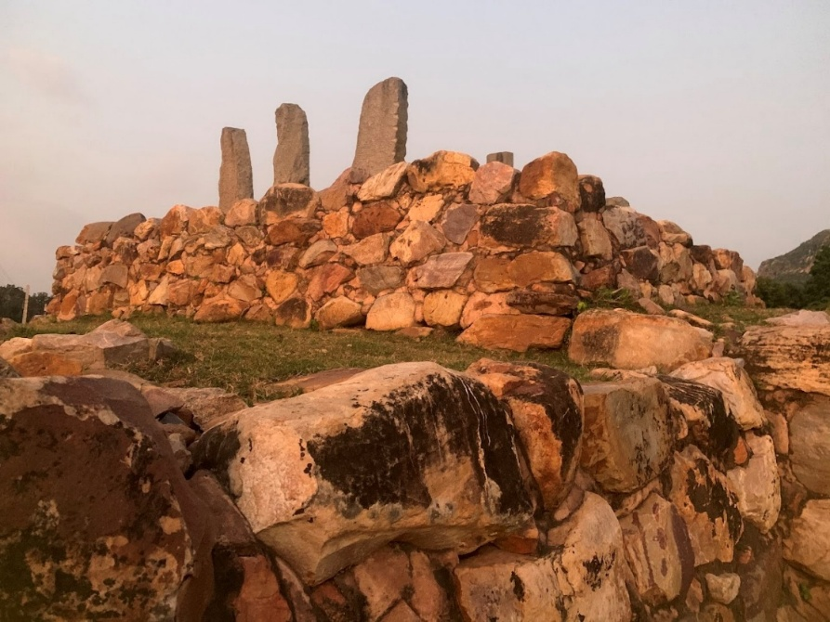

**The image of a stupa believed to contain the relics of the Buddha built by King Ajatasattu of Magadha at Rājagaha (This was a discovered -in 1997, Archaeological Survey of India** (ASI) [6] .

### 2. Relic Stupa of the Licchavis – Vesālī (Vaishali, Bihar)

At Vesālī, the noble Licchavis—fiercely devoted to the Buddha—enshrined his relics in a stupa that still stands today, preserved and honoured. Archaeologists have dated the site as early as the 5th century BCE, making it one of the oldest known stupas. Its graceful hemispherical shape guards the sacred relics from the ravages of time. [7]

To walk here is to walk where the Blessed One walked. Here, he taught the Dhamma to laypeople and monastics alike. As followers of the Tathāgata, when we bow before this stupa, we do so not merely before a monument, but before the living presence of wisdom and compassion that still stirs the heart.

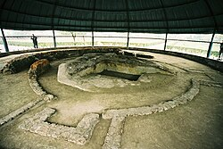

**Relic Site in Veshali [8]**

### 

**Present day image of the Relic Stupa in Vesali [9]**

### 3. Relic Stupa of the Sakyans – Kapilavatthu (Piprahwa, India / Tilaurakot, Nepal)

The Sakyans—relatives of the Buddha—built a stupa in his honour in Kapilavatthu, his ancestral home. Today, two sites—**Piprahwa** (in India) and **Tilaurakot** (in Nepal)—both lay claims to being ancient Kapilavatthu. Each site bears witness to early Buddhist activity, including stupas and monastery ruins. [10] (See Section:2).

In 1898, a British engineer, William Claxton Peppé, unearthed a casket at Piprahwa bearing an inscription referencing the Buddha and his Sakyan community—possibly relics once enshrined by his own kin. [11]  Meanwhile, Tilaurakot, with its impressive ruins and sacred history, is under review for World Heritage status. Both sites, merely 39 km apart and near Lumbini—the Buddha’s birthplace—are imbued with the presence of the Tathāgata. [12] (see the picture below)

Whether one stands at Piprahwa in India or Tilaurakot, in Nepal one stands on holy ground—land that felt the Blessed One’s footprints when he was a child prince, a returned ascetic, and a wise teacher. May those who visit these sites be stirred by faith and gratitude. May their hearts awaken to the profound legacy of the Buddha’s boundless compassion and the path he so kindly opened for the welfare of all beings!

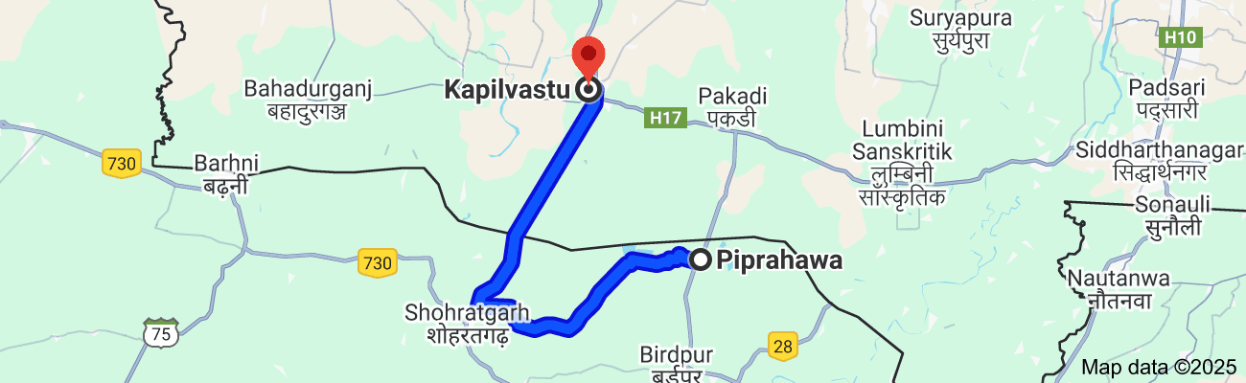

**Map showing the location of Piprahawa in UP and Kapilvastu in Nepal. (distance between these two places is 39 km) [13]**

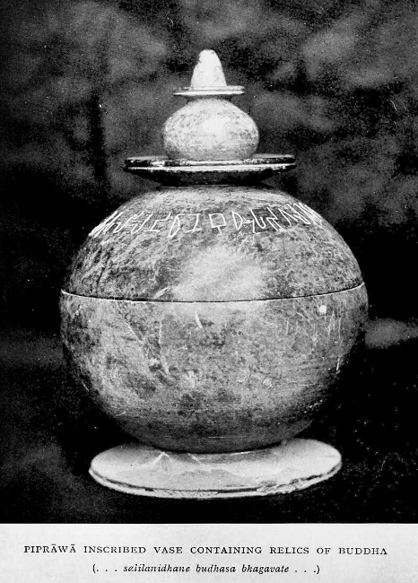

**Piprahawa vase with relics of the Buddha. The inscription reads *...salilanidhane Budhasa Bhagavate...* "Relics of the Buddha Lord [14]**

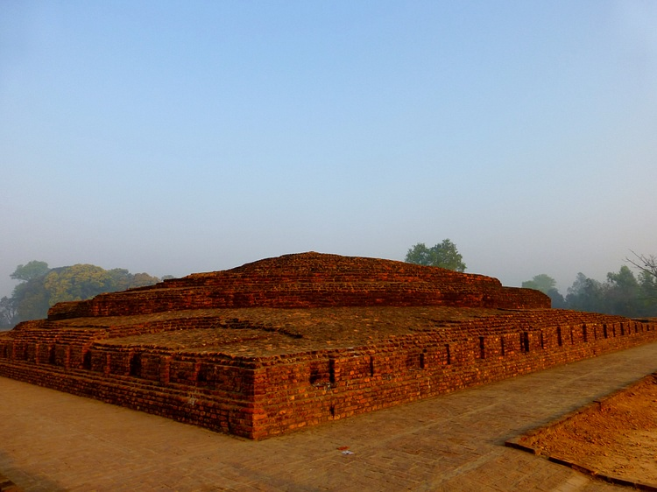

**Brick**[**stupa**](https://www.worldhistory.org/stupa/)**at Piprahawa believed to contain relics of the Buddha [15]**

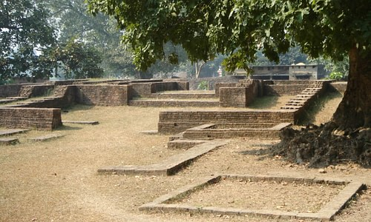

**Ruins of ancient Kapilavattu royal city of Sakyans [16]**

### 4) The Relic Stupa Built by the Bulayas of Allakappa

The ancient city of **Allakappa**, where the Bulayas enshrined a portion of the Buddha’s relics, remains an enigmatic site. Scholars speculate that Allakappa may correspond to **present-day Areraj** in the East Champaran district of Bihar. Areraj is historically significant and houses an Ashokan pillar, indicating its sacred status. The very name *Areraj* may carry echoes of *Allakappa*—or perhaps even of **Āḷāra Kālāma**, one of the Blessed One’s early teachers. [17]

After his conversion to the Dhamma, **King Asoka the Great** undertook an extensive pilgrimage across northern India, commemorating sacred Buddhist sites with *Dhamma stambhas* (Ashokan pillars). One such pillar stands in **Lauriya Areraj**, near **Nandangarh**, underscoring the site’s ancient importance. The ***Archaeological Atlas of Bihar*** documents these Ashokan monuments and supports the view that this region could indeed be ancient Allakappa (see map below). [18]

Although no definitive archaeological evidence of the original stupa has yet been uncovered, tradition and the presence of the Ashokan pillar affirm the area's connection to the Buddha’s relics. [19] If this is the sacred ground where the **Bulayas of Allakappa** received and enshrined relics of the Blessed One, then a visit here—amid the silence of ancient stones and the whisper of the river breeze—may stir deep faith in our hearts and renew our resolve to walk the Noble Path toward liberation!

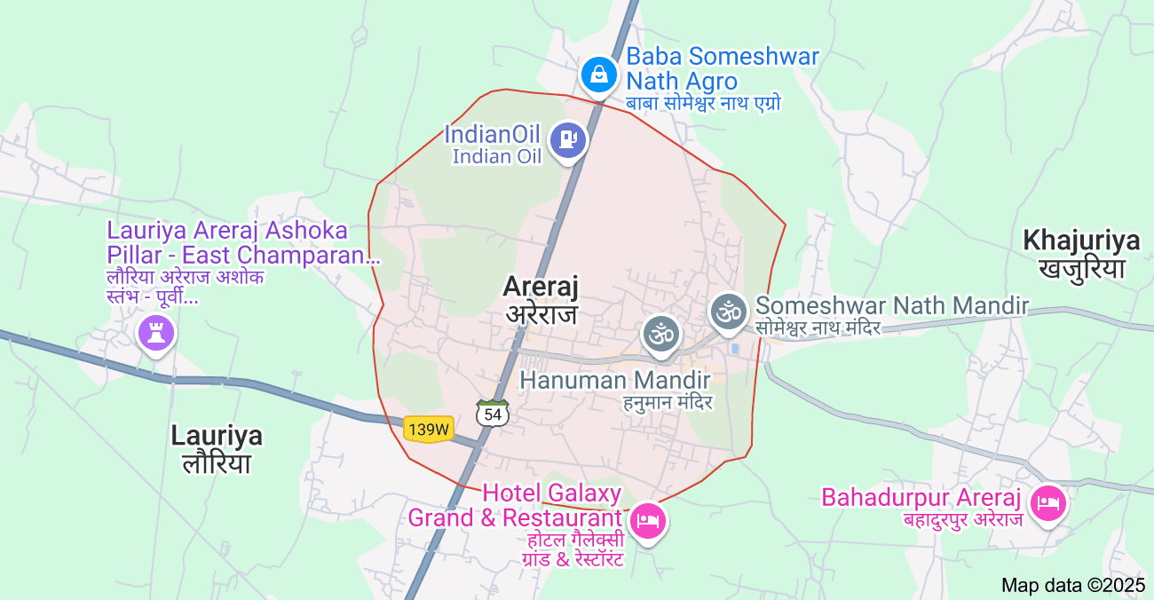

**Map showing the location of Ashoka Pillar in Lauriya Areraj [20]**

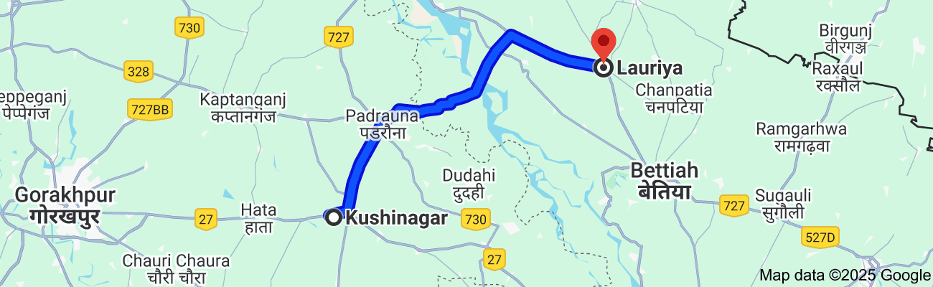

**Distance from Kusinara to Areraj, Lauriya is 77km**

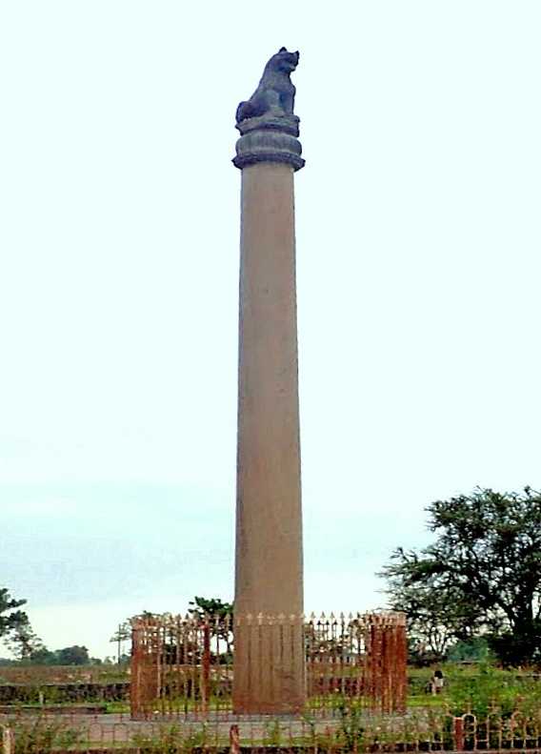

**The**[**Pillar of Ashoka**](https://en.wikipedia.org/wiki/Pillars_of_Ashoka)**at Lauria Nandangarh [21]**

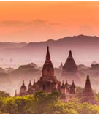

**Impression of an artist: Relics Stupa of Ancient Allakappa**

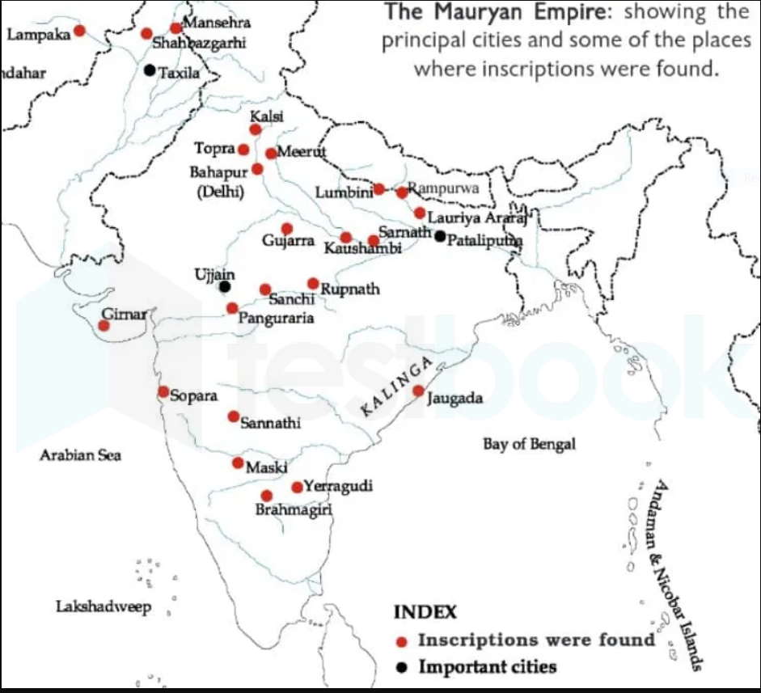

**Map showing the places where the Asoka Pillars/inscriptions were located - Lauriya Pillar is marked North of Patlaiputta (Patna)[22]**

5) The Relic Stupa Built by the Koliyas of Ramagrama

Among all the ancient stupas enshrining the Buddha’s relics, **the Ramagrama Stupa** stands uniquely sacred—it is believed to be the **only original and undisturbed relic stupa** in existence. [23]

Built by the **Koliyas of Ramagrama**—relatives of the Blessed One through his mother, Queen Māyādevī—this stupa rises from the fertile plains of **Nawalparasi District** in the Lumbini Zone of Nepal. Historical records affirm that after the cremation of the Blessed One at Kusinārā, the Koliyas carried their portion of the relics to Ramagrama and enshrined them with deepest reverence.

Discovered as a large mound in 1899 and further confirmed through studies in 1964, the **Ramagrama Stupa** remains unexcavated to this day, preserved in its pristine form. As such, it is an extraordinary site of pilgrimage for Buddhists around the world—a living symbol of unbroken faith and devotion. [24]

To visit Ramagrama is to stand before history untouched—a sacred space where the dust once carried the footprints of the Enlightened One’s kin. In its silent stillness, we may feel the radiant presence of the Buddha and find renewed confidence in the Dhamma he compassionately revealed.

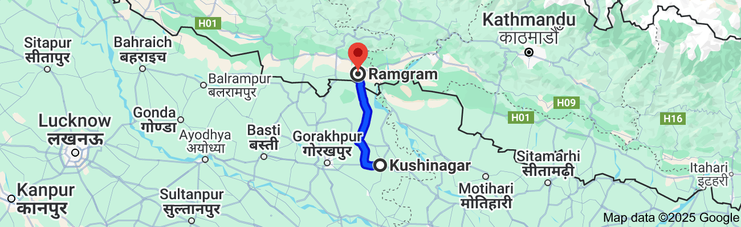

**Distance from Kushinagar, UP to Ramgram in Nepal, 114 km [25]**

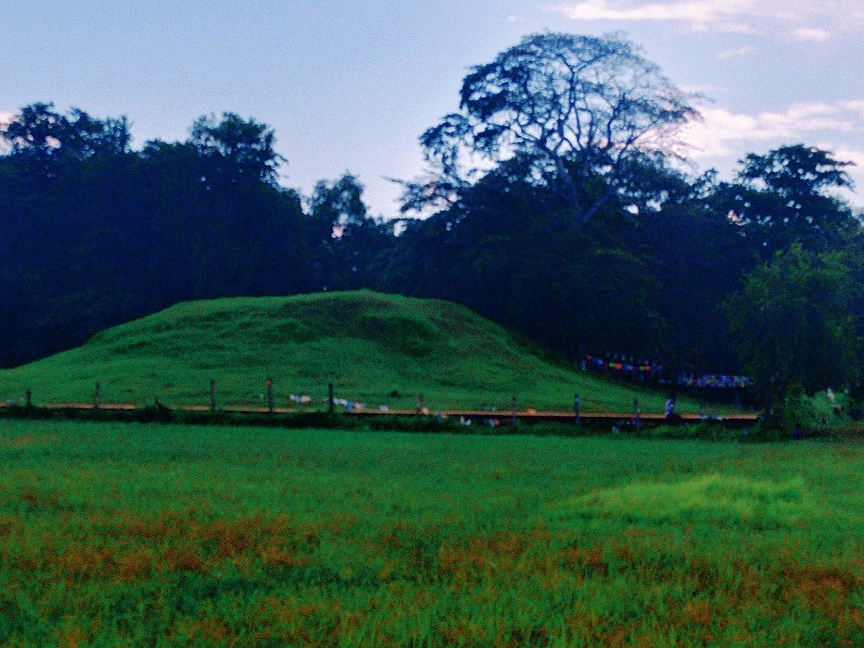

**View of Ramagrama stupa, Parasi district, Nepal [26]**

### 6) The Relic Stupa Built by the Brahmin of Vethadīpa

The exact location of ancient **Vethadīpa** is unknown, but scholars propose that it may correspond to **Jahangira**, a rocky island in the **Ganges River** near **Sultanganj** in Bihar. The very name *Vethadīpa* hints at its nature (*dīpa* meaning “island”), and Jahangira is notable as the only **permanent rocky island** along the Ganges, standing steadfast amid the flowing waters. [27]

Renowned scholar **Bhante S. Dhammika** writes movingly of his visit to Jahangira: [28]

a striking cluster of boulders rising from the Ganga, crowned with temples and ancient carvings. Among these stones are **Buddhist sculptures**, including a standing image of the Buddha with the *abhaya mudrā* (gesture of fearlessness), dating from the 5th century CE. Another figure—possibly a donor—and an image of Tara holding a lotus further reveal the island’s rich Buddhist heritage (see the image below).

Although no visible remains of a relic stupa are found today, the historical evidence strongly suggests that **Vethadīpa**—perhaps this very island—was once a flourishing Buddhist centre. The **Brahmin of Vethadīpa**, moved by the Buddha’s final teachings, is said to have journeyed to Kusinārā to receive a portion of the Blessed One’s relics, which he enshrined in a stupa now lost to time.[29]

But even in the absence of a visible monument, the presence of these ancient Buddhist images on the island speaks to the **devotion and practice of Dhamma** in this region long ago. To visit Jahangira is to walk amid silent witnesses of the past. Here, a heartfelt offering, a moment of stillness, or a single word of gratitude may awaken the same faith that once inspired the Vethadipa Brahmins to honour the Blessed One’s memory.

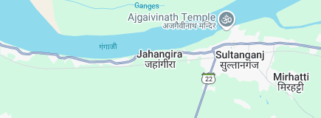

**Jahangira located on a rocky island near the banks of Ganges[30]**

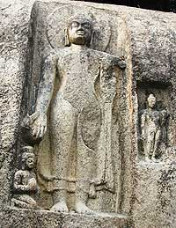

**Standing image of the Buddha with the *abhaya mudrā* at modern-day Jahangira** [31]

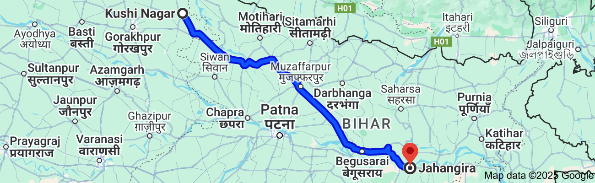

**Distance from Kushinagar, UP to Jahangira in Bihar is 358 km**



**An artist’s impression of ancient Vetahdipa Relic Stupa on the rocky island of Ganges River Bank**

## 7) The Relic Stupa built by Mallas of Pava

The precise location of ancient Pāvā is not known with certainty. However, based on the discovery of ancient ruins believed to be Buddhist, scholars suggest that modern-day Fazilnagar in the Kushinagar district could be the location of this ancient Malla city. A large flat-topped mound known as **Jharmatiya** (ASI SL.# N-UP-P21), located in present-day Chetiaon, is considered to be the site of a stupa possibly built where **Cunda’s** house once stood.) [32] Cunda was the lay devotee who offered the Blessed One his final meal (see Section 19-4).

According to the eminent archaeologist **Dilip Chakrabarti**, this mound—about 20 km from Kusinara—may be identified with ancient Pāvā. [33] Although the precise location of the relic stupa is lost to time, we know that the Blessed One passed through this region on his final journey to Kusinara. Perhaps the echo of his sacred footsteps still resounds along this path. While the original stupa may no longer be visible, the earth here may still carry the blessings of the Sublime One. By visiting this place, we may gladden our hearts, recollect the Buddha’s boundless compassion, and deepen our devotion.

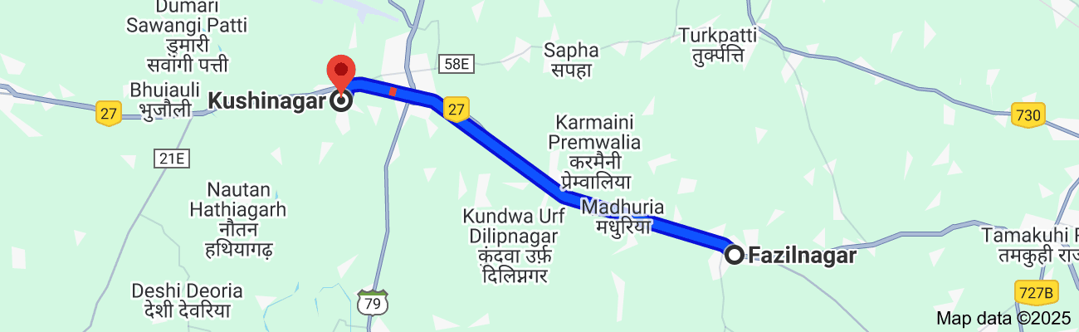

**Distance from Fazlinagar to Kushinagar is 19 km[34]**

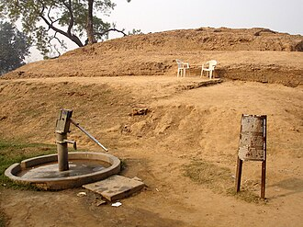

**A stupa built at the place where**[**Cunda's**](https://en.wikipedia.org/wiki/Cunda_Kamm%C4%81raputta)**house used to be, in ancient Pava (present-day [Fazilnagar](https://en.wikipedia.org/wiki/Fazilnagar" \o "Fazilnagar)) [35]**



**The Ancient Relic Stupa of Pava built by Mallas may have look like this (an impression of an artist)**

### 8) The Relic Stupa Built by the Mallas of Kusinara

The **Ramabhar Stupa**, also known as **Mukutbandhan Chaitya**, was built over a portion of the Buddha’s relics at the very place where his cremation took place in Kusinara (see Section 19-6 for more details). This immense stupa was uncovered during archaeological excavations in 1910 and is surrounded by smaller stupas and remains of ancient Buddhist viharas.

Nearby stands the **Mahaparinirvana Temple**, marking the sacred spot of the Blessed One’s Parinibbāna. [36]

To honour this hallowed ground—where the Buddha, the Teacher of gods and humans, was cremated—is to honour the immeasurable compassion that he embodied. May our pilgrimage to this sacred place deepen our faith, cultivate wisdom, and fill our hearts with gratitude for the peerless Guide.

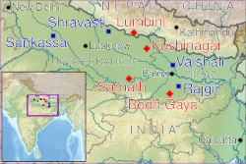

**Location of Kusinara in Ancient India[37]**

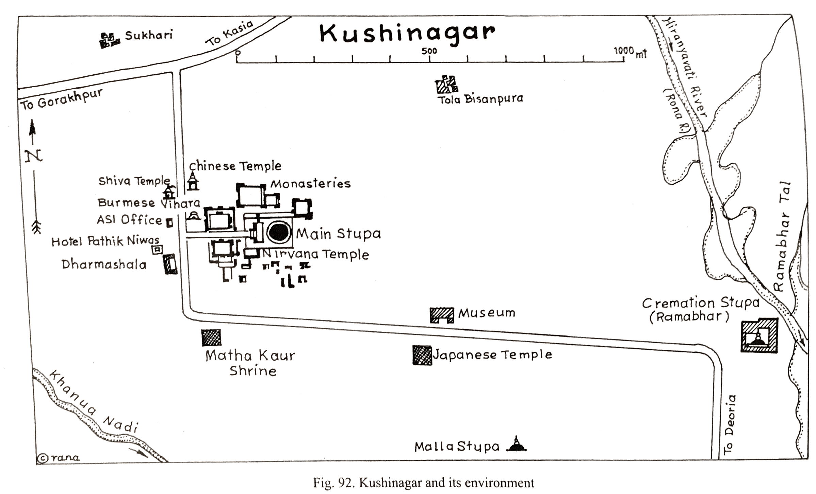

**Map showing the location of Nirvana Temple and Ramabhar Stupa [38]**

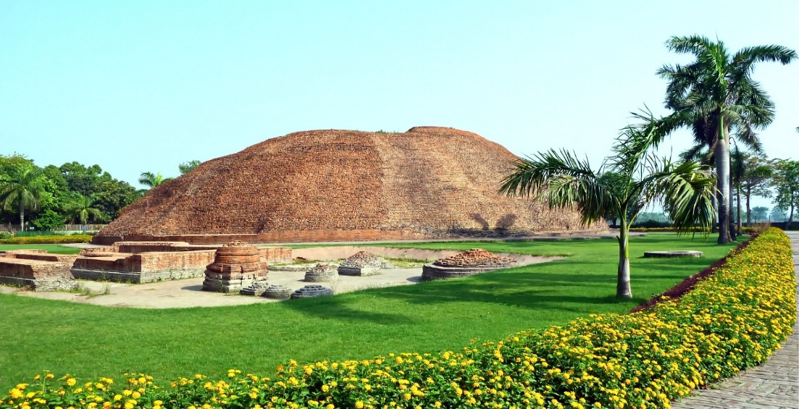

**Ramabhar Stupa- Relic Stupa Buil by Mallas of Kusinara [39]**

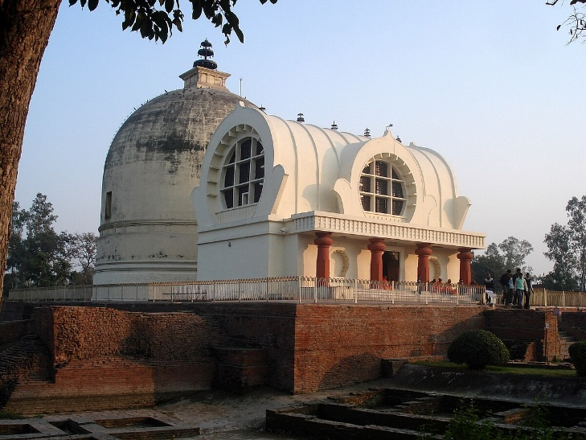

**The Parinirvana Temple with the Parinirvana Stupa, Kushinagar[40]**

### 9) The Great Stupa Built by the Moriyas of Pipphalivana

During the time of the Blessed One, the Moriyas formed a republic (*gaṇasaṅgha*) located northeast of the Malla Kingdom, with the Koliyas—another Sakyan clan—as their northern neighbours. Their capital was Pipphalivana. [41] After the Parinibbāna of the Blessed One, the Moriyas arrived at Kusinara seeking a share of the relics. Though all eight portions had already been distributed, they were content to receive embers from the cremation fire. With deep reverence, they enshrined them in a stupa in Pipphalivana. [42]

Scholars suggest that Pipphalivana may have been located between Rummindei (Lumbini) in Nepal’s Terai region and Kasia in modern Gorakhpur district, Uttar Pradesh. The town is believed to be identified with Nyagrodhavana (Banyan Grove), which housed the famed Embers Stupa and was visited by the Chinese pilgrim Hiuen Tsang. Fa-Hien noted that the site lay four *yojanas* east of the Anoma River and twelve *yojanas* west of Kusinara. [43]

Though the exact location remains uncertain, modern Gorakhpur district, situated on the banks of the Rapti River, is considered a likely candidate for the ancient Moriya republic (see the map below). Extensive archaeological findings from the area support this view. The **Government Bauddha Museum** in Gorakhpur preserves antiquities from this spiritually rich region, which has nurtured many great teachers—Tirthankara Mahāvīra, the Buddha, Guru Gorakhnath, and Kabir .[44]

Important archaeological sites such as Lahuradeva and Sohagaura—both near Gorakhpur—further underscore the region’s ancient heritage. Lahuradeva, dated to as early as 6000–7000 BCE, is among the world’s oldest known sites for rice cultivation. [45] Sohagaura, dated between 4000 and 2000 BCE, yielded the Sohgaura copper plate inscription—one of the earliest known examples of the Brahmi script from the Mauryan period. [46]

Though we may not stand before the exact relic stupa today, we can take heart knowing that the Moriyas of Pipphalivana, devoted followers and relatives of the Sakyans, lovingly built a stupa to honour the Enlightened One. If you visit this ancient land, dear reader, may you feel the presence of those faithful lay disciples and rekindle your confidence in the Blessed One—he who showed the True Path out of the suffering of *saṃsāra*.

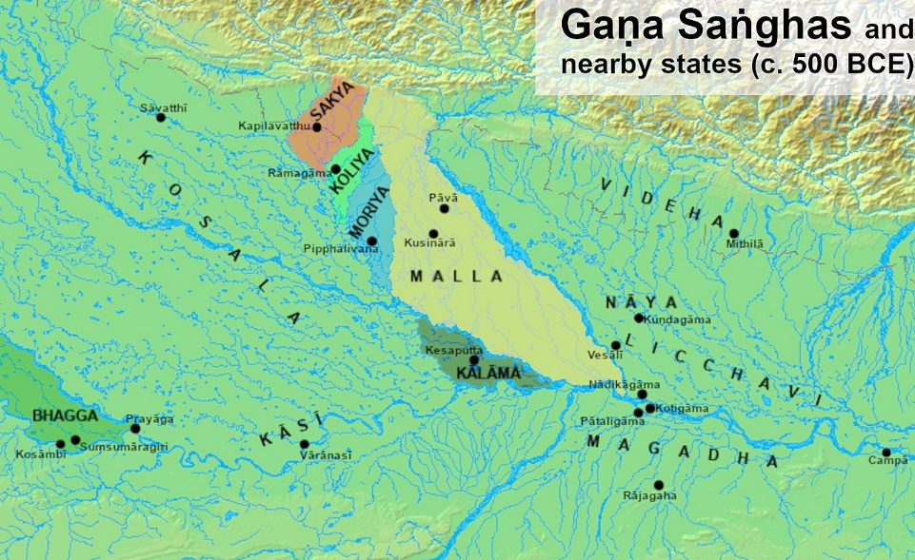

**Location of Moriya Kingdom and the capital city Pipphalivana in Ancient India [47]**

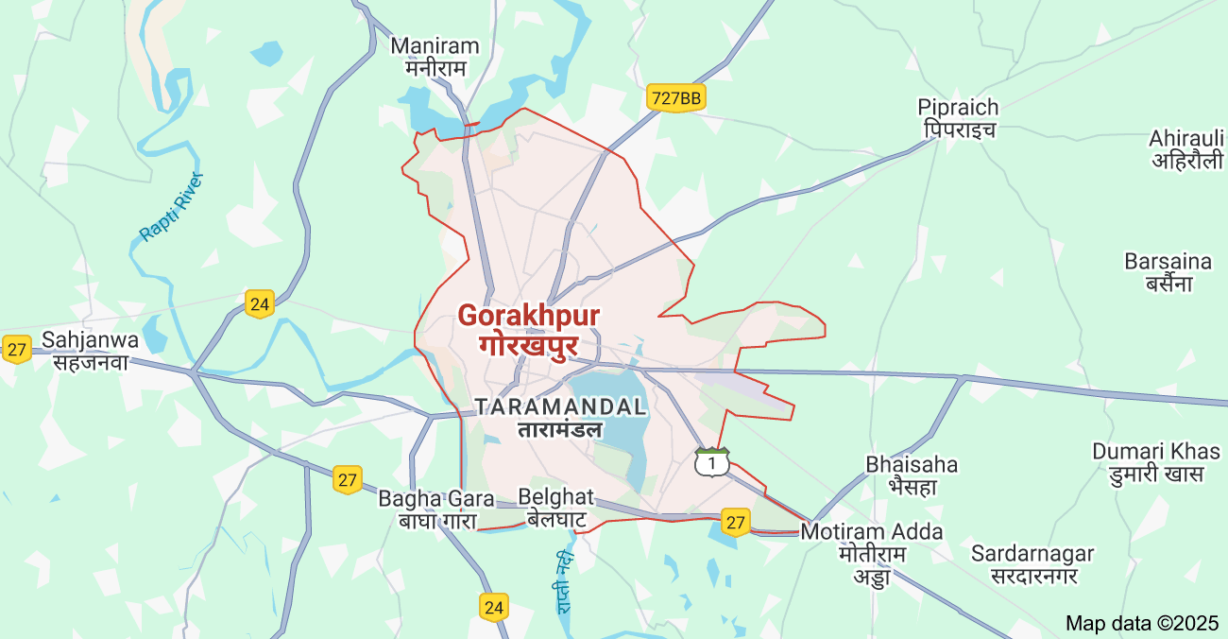

**Location of Gorakhpur District in UP.[48]**

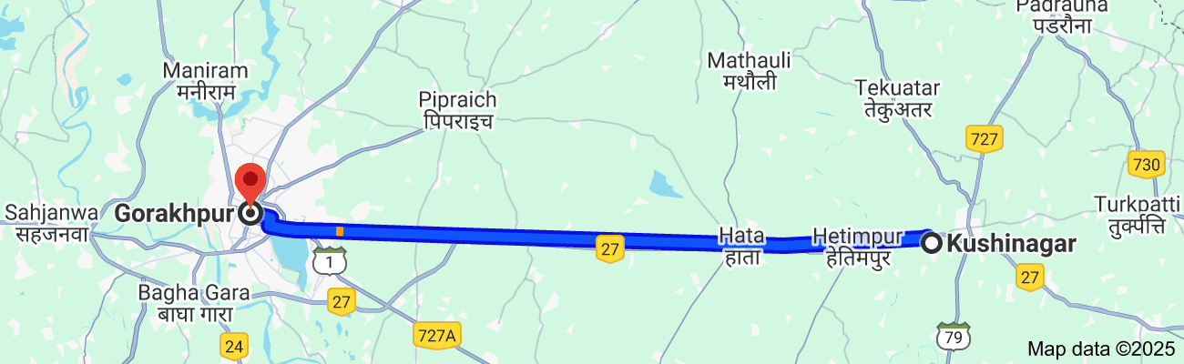

**Distance between Kushinagar to Gorakhpur is 53 km[49]**

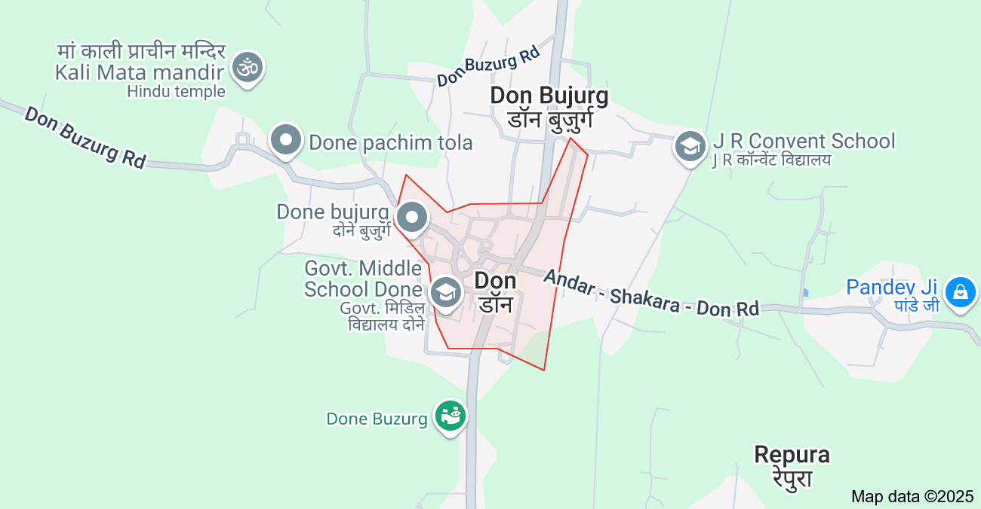

**Map showing the location of Don village in, Siwan district in Bihar[50]**

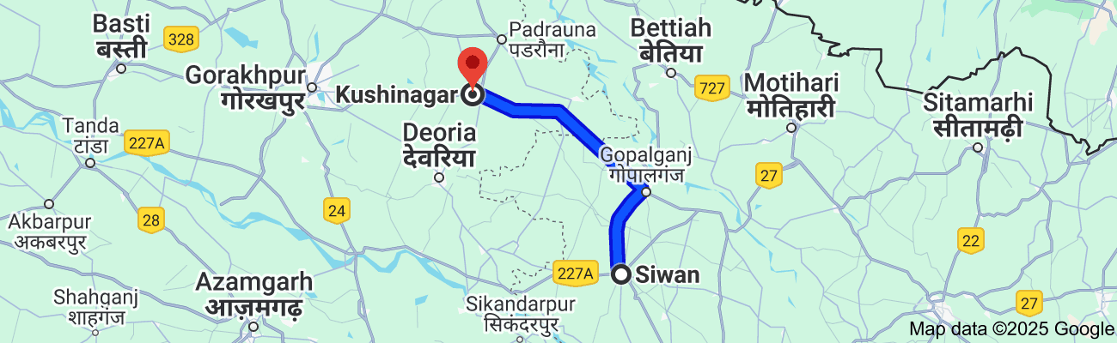

**Distance from modern day Don village of Siwan district to Kushinagar is 100 km**

### 10. The Relic Stupa of the Urn Built by the Brahmin Doṇa

In Section 19.6, we encountered the noble figure of the Brahmin Doṇa, a devoted follower of the Blessed One. As a man who deeply understood the Dhamma, Doṇa acted with remarkable wisdom and faith during a critical moment—when tensions arose among kings, chieftains, and relatives over the division of the Buddha’s relics following his cremation at Kusinārā. True to the teachings he had embraced, Doṇa intervened to prevent conflict, preserving harmony among those who wished to honour the Master.[51]

The scriptures recount that Doṇa first met the Buddha along the highway between Ukkaṭṭhā and Setavya (AN 4.36). After listening to the Blessed One’s teaching, he attained the stage of a non-returner (anāgāmī) and became a devoted disciple of the Triple Gem. [52]

According to ancient sources, it was this same Brahmin Doṇa who constructed a stupa to enshrine the urn that had held the Buddha's relics. This monument became known as Doṇa’s Stupa. It is believed to be located near the village of Don (also spelled Dong) in the Siwan district of Bihar. Historically, this region was part of the Kosala Kingdom[53] and is noted for its sacred associations. [54].

Records from the Chinese pilgrim Hiuen Tsiang mention that the stupa had already fallen into ruin by the time of his visit, yet it still occasionally emitted a mysterious radiant light—testimony, perhaps, to the lingering sanctity of the site. [55]. Today, what remains is a grassy mound crowned with a small Hindu temple, quietly standing just outside the village. [56]. Researcher Krishna Kumar Singh affirms that the Buddha’s association with the Siwan region remains undisputed. .[57]

Despite these accounts, the exact location of the original stupa built by the faithful Doṇa remains elusive—perhaps hidden beneath centuries of earth and time. Yet, whether the stupa is rediscovered or not, one truth remains certain: the enduring presence of the Buddha is not dependent solely on relics or monuments. We, as devoted followers, still possess the most precious legacy—the Dhamma, his timeless and liberating teaching.

And still, let us not forget the compassionate advice the Blessed One gave in his final moments—that visiting the sacred places connected to his life brings great benefit, especially for lay followers. Such pilgrimages can rekindle faith, deepen understanding, and strengthen our resolve along the Noble Path. Thus, a journey to the humble village of Don—once touched by the presence of a noble disciple—can itself become an act of devotion, a quiet reaffirmation of our trust in the Buddha, the Dhamma, and the Sangha.

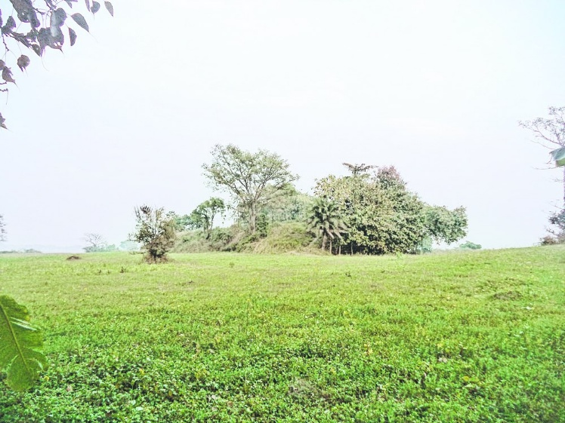

**Modern day image of Don village [58]**

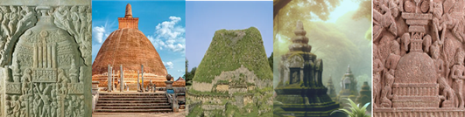

### Where Relics Sleep

Beneath the grass, where silence grows,  
The stupa sleeps, yet still it glows.  
Though time may hide what hands once raised,  
The heart remembers, deeply praised.

No stone, no mound, no earthly urn  
Can match the light for which we yearn.  
For in the Dhamma, pure and bright,  
The Buddha’s presence shines in light.

Still, blessed is the path we tread,  
To walk where ancient footsteps led—  
Where Doṇa stood with heart so still,  
His offering shaped by deepest will.

O pilgrim soul, do not despair,  
Though relics fade, the truth is there.  
Each step, each bow, each silent prayer  
Calls forth the wisdom everywhere.

And when we kneel on sacred land,  
With folded palms and open hand—  
We find again, not bone nor dust,  
But boundless faith, and silent trust.



### Endnotes: Appendix 1

1. AI created image.
2. Map source: <https://en.wikipedia.org/wiki/Mahajanapadas#/media/File:Mahajanapadas_(c._500_BCE).png>
3. [Newly Excavated Stupa Rajgir - Indian Vagabond](https://indianvagabond.com/2024/11/18/newly-excavated-stupa-rajgir/)
4. Source: <https://www.bihar.world/home/buddhist-sites/> .
5. Source: <https://www.bihar.world/home/buddhist-sites/#:~:text=R%C4%81jagaha%3A%20Magadh%20King%20Ajatashatru%20erected,for%20a%20very%20long%20time> .
6. A detailed report of the stupa is given here. <https://indianvagabond.com/2024/11/18/newly-excavated-stupa-rajgir/> * A site located very near to [Chariot Wheel Marks](https://indianvagabond.com/2024/11/14/chariot-wheel-mark-and-shell-characters/) is the **Newly Excavated Stupa**. The official board outside the site only mentions this as a newly excavated stupa with no other dates or details mentioned. *   Archaeologists claim to have discovered the largest stupa in the world. The stone structure, built by King Ajatasatru, is mentioned in ancient Buddhist texts and in the accounts of foreign travellers but was buried in the sands of time for thousands of years. Stupas were built over the relics of Lord Buddha after his death in 483 BC in Kushinagar: <https://www.telegraphindia.com/india/largest-stupa-found-in-rajgir/cid/928309>
7. <https://en.wikipedia.org/wiki/Relic_Stupa_of_Vaishali>
8. Source: <https://en.wikipedia.org/wiki/Relic_Stupa_of_Vaishali>
9. Ibid.
10. Source: <https://en.wikipedia.org/wiki/Kapilavastu_(ancient_city)>
11. Iin 1898, William Claxton Peppe discovered five small vases containing bone fragments, ashes, and jewels in a long-forgotten stupa in [Piprahwa](https://en.wikipedia.org/wiki/Piprahwa), near [Birdpur](https://en.wikipedia.org/wiki/Birdpur) in the Basti district of [Uttar Pradesh](https://en.wikipedia.org/wiki/Uttar_Pradesh), India. A team led by K.M. Srivastava performed further excavations at the Piprahwa site between 1971 and 1973. The team discovered a casket containing fragments of charred bone and dated them to the 4th or 5th century BCE.[[44]](https://en.wikipedia.org/wiki/Relics_associated_with_Buddha#cite_note-Srivastava1980-45) Based upon the findings of these excavations, the [Archaeological Survey of India](https://en.wikipedia.org/wiki/Archaeological_Survey_of_India) (ASI) has identified Piprahwa as Kapilavastu: <https://en.ikipedia.org/wiki/Relics_associated_with_Buddha>
12. Source: <https://vajiramandravi.com/upsc-daily-current-affairs/prelims-pointers/kapilvastu-relics/>
13. Google Maps
14. [**https://en.wikipedia.org/wiki/Piprahwa**](https://en.wikipedia.org/wiki/Piprahwa) **\* Piprahwa is a village near**[**Siddharthnagar city**](https://en.wikipedia.org/wiki/Siddharthnagar)**in**[**Siddharthnagar district**](https://en.wikipedia.org/wiki/Siddharthnagar_district)**of the**[**Indian state**](https://en.wikipedia.org/wiki/States_and_union_territories_of_India)**of**[**Uttar Pradesh**](https://en.wikipedia.org/wiki/Uttar_Pradesh)
15. Brick [**stupa**](https://www.worldhistory.org/stupa/) at Piprahwa, discovered by William Claxton Peppe in the late 19th century CE. The stupa and other artifacts on site strongly suggested that Piprahwa was ancient [**Kapilavastu**](https://www.worldhistory.org/Kapilavastu/). However, the other possiblity, Tilaurakot was not dismissed as the site of Kapilavastu but, owing to the finds at Piprahwa, was not confirmed either. <https://www.worldhistory.org/image/12881/stupa-at-piprahwa/>
16. Source: <https://www.worldhistory.org/Kapilavastu/>
17. Source: <https://en.wikipedia.org/wiki/Areraj>
18. Archaeological Atlas by Vivek Kumar Singh: <https://bhds.in/Images/BVVS%20Website%201.pdf>
19. This Lofty stone column erected by priyadarshee Lord Ashok in 249 BC in village Lauriya under Areraj subdivision is situated on the left side of Areraj – Bettiah road. The pillar, known as “Stambh dharma lekh”, which bears in well preserved and well cut letters six of his edicts, is a single block of polished sandstone, 36 ½ feet in height above the ground with a base diameter of 41.8 inches and a diameter at the top of 37.6 inches. The weight of this portion only is very nearly 34 tons, but as these must be several feet of the shaft sunk in the earth. The actual weight of the whole block must be about 40 tons. This pillar has no Capital. According to a report that pillar was crowned with a statue of an animal, but it was transferred to the Kolkata museum. The edicts of king Ashoka are most clearly and heartily engraved, and are divided into two distinct portions, that to the worth containing 18 lines and that to the south 23 lines. But now these are not a good state of preservation and suffered from the effect of weather. The villages call the pillar as ‘Laur’ that is the phallus and the adjoining village is named after it Lauriya. The Archaeological Survey of India has classified the Ashokan pillar as a protected monument. <https://eastchamparan.nic.in/tourist-place/ashokan-pillar-lauria-areraj/#:~:text=The%20pillar%2C%20known%20as%20%E2%80%9CStambh,the%20top%20of%2037.6%20inches>.
20. Goole Maps
21. <https://en.wikipedia.org/wiki/Lauria_Nandangarh>
22. Source: <https://testbook.com/question-answer/ashokan-inscriptions>
23. <https://visitworldheritage.com/en/buddha/ramagrama-stupa/c0b00737-7dd2-4817-9449-0ff69f78125a>
24. <https://visitworldheritage.com/en/buddha/ramagrama-stupa/c0b00737-7dd2-4817-9449-0ff69f78125a>
25. Google Maps
26. <https://en.wikipedia.org/wiki/Ramagrama_stupa#/media/File:Ramgram_Stupa_12.jpg>
27. Source: <https://www.nationalheraldindia.com/india/archaeological-atlas-of-bihar-the-first-in-india-puts-spotlight-back-on-history>
28. Source: <https://www.buddhistchannel.tv/index.php?id=18,5550,0,0,1,0>
29. DN:16
30. Google Maps
31. Source: <https://www.buddhistchannel.tv/index.php?id=18,5550,0,0,1,0>
32. Source: <https://archives1.dailynews.lk/2022/05/16/features/278876/buddha%E2%80%99s-last-journey>
33. Source: <https://archives1.dailynews.lk/2022/05/16/features/278876/buddha%E2%80%99s-last-journey>
34. Google map
35. Source: <https://en.wikipedia.org/wiki/P%C4%81v%C4%81>
36. [Alexander Cunningham](https://en.wikipedia.org/wiki/Alexander_Cunningham) gains the most attention for his work in the area, because he conclusively proved that Gautama Buddha had died in the area. The present temple was built by the [Indian Government](https://en.wikipedia.org/wiki/Indian_Government) in 1956 as part of the commemoration of the 2,500th year of the Mahaparinivana or 2500 BE (Buddhist Era). Inside this temple, there is a Reclining Buddha image lying on its right side with the head to the north. The statue is 6.1 m long and rests on a stone couch. <https://en.wikipedia.org/wiki/Parinirvana_Stupa>.
37. Source: https://en.wikipedia.org/wiki/Kushinagar
38. Source: [Kushinagar – Evolution of Buddhist Sites](https://blogs.ubc.ca/asia250buddhistsites/kushinagar/)
39. Source: <https://www.flickr.com/photos/asienman/51438694745>
40. <https://en.wikipedia.org/wiki/Parinirvana_Stupa>
41. <https://en.wikipedia.org/wiki/Moriya_(tribe)>
42. DN:16
43. Source: <https://en.wikipedia.org/wiki/Pipphalivana>.
44. Source: <https://gorakhpur.nic.in/about-baudhh-museum/>.
45. <http://architecturalheritage.intach.org/?p=1034>
46. <https://en.wikipedia.org/wiki/Sohgaura_copper_plate_inscription>
47. Source: <https://en.wikipedia.org/wiki/Moriya_(tribe)#/media/File:Gana_Sanghas_(c._500_BCE).jpg>
48. Google Maps
49. Ibid.
50. Google Maps
51. DN:16
52. “At the end of the discourse, the brahmin attained three paths and fruits and, in 12,000 phrases, spoke the praise called ‘Doṇa’s Thunder’; see: AN: Note: 699.
53. Source: <https://en.wikipedia.org/wiki/Siwan_district>
54. Source: <https://www.bihar.world/home/buddhist-sites/>.
55. Source: <https://www.buddhanet.net/e-learning/pilgrim/pg_04/>
56. Source: <https://www.buddhanet.net/e-learning/pilgrim/pg_04/>
57. [https://www.telegraphindia.com/bihar/buddha-circuit-skips-siwan-despite-research-links/cid/1338088*](https://www.telegraphindia.com/bihar/buddha-circuit-skips-siwan-despite-research-links/cid/1338088*) "An English archaeologist, Dr Hoye, first brought this place to light in 1899. He discovered Indo-Bactrian coins here. There is a big mound here where idols of Buddha and *mridubhands* are found. The ASI is about to start excavation work here."
58. Source: <https://www.telegraphindia.com/bihar/buddha-circuit-skips-siwan-despite-research-links/cid/1338088>